LAB SESSION 9
Programming Exercise:
Question 1: Create an abstract class Shape with a pure virtual function area(). Derive two classes Circle and Rectangle from Shape. Implement the area() function in both derived classes. Write a program to calculate the area of a circle and a rectangle.

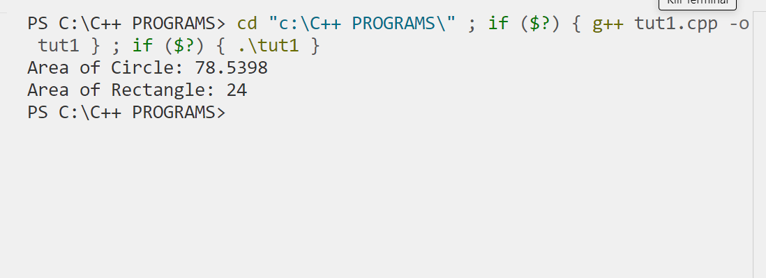

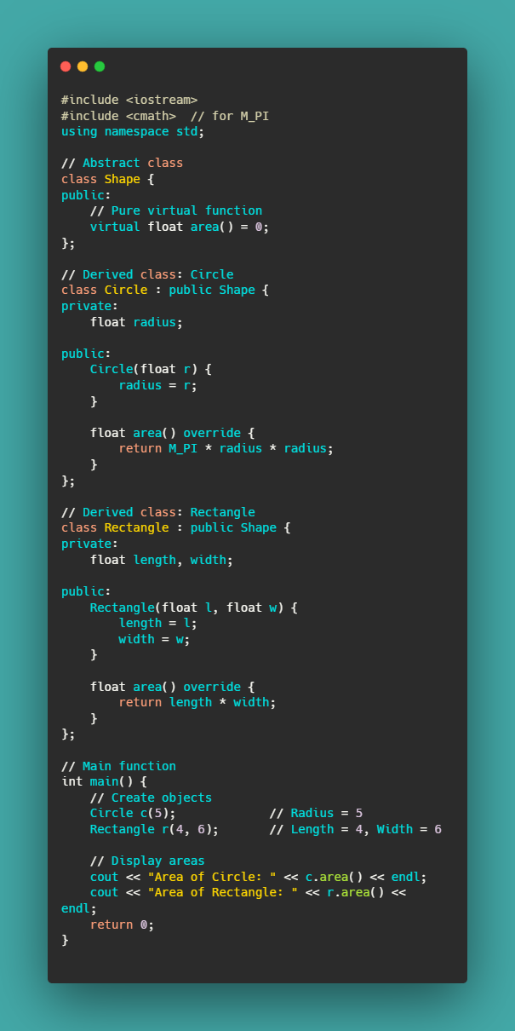
Question 2: Create an abstract class Employee with a pure virtual function calculateSalary(). Derive two classes PermanentEmployee and ContractEmployee from Employee. Implement the calculateSalary() function in both derived classes. Write a program to calculate the salary of a permanent employee and a contract employee.

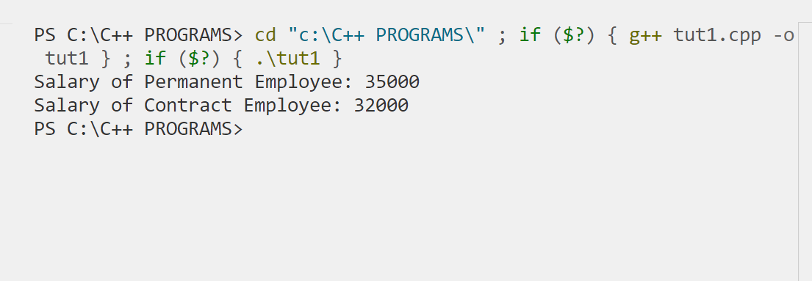

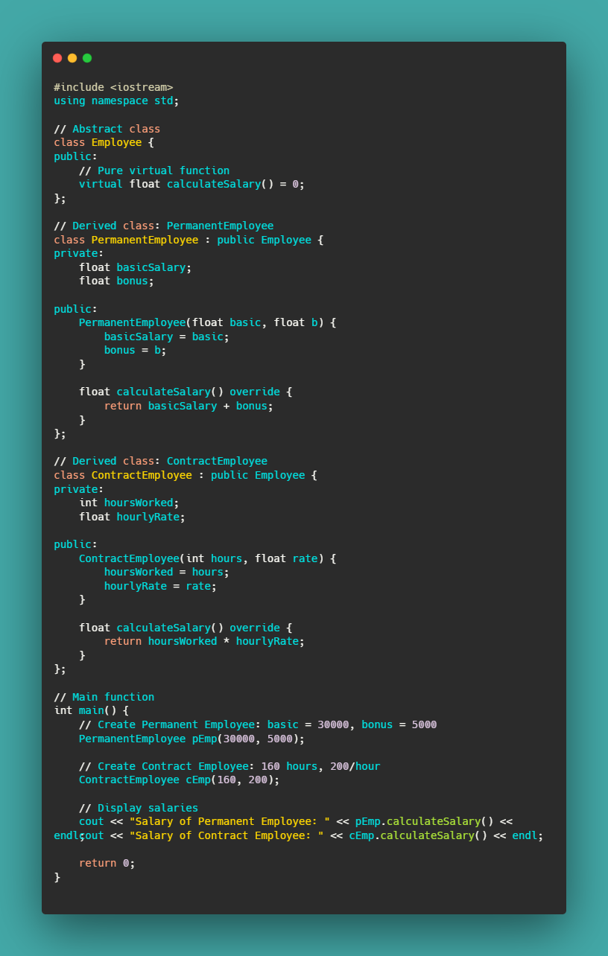
Question 3: Create an abstract class Vehicle with a pure virtual function fuelEfficiency(). Derive two classes Car and Truck from Vehicle. Implement the fuelEfficiency() function in both derived classes. Write a program to calculate the fuel efficiency of a car and a truck.

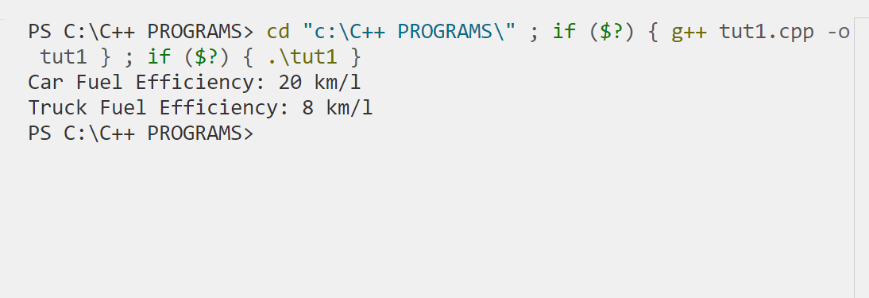

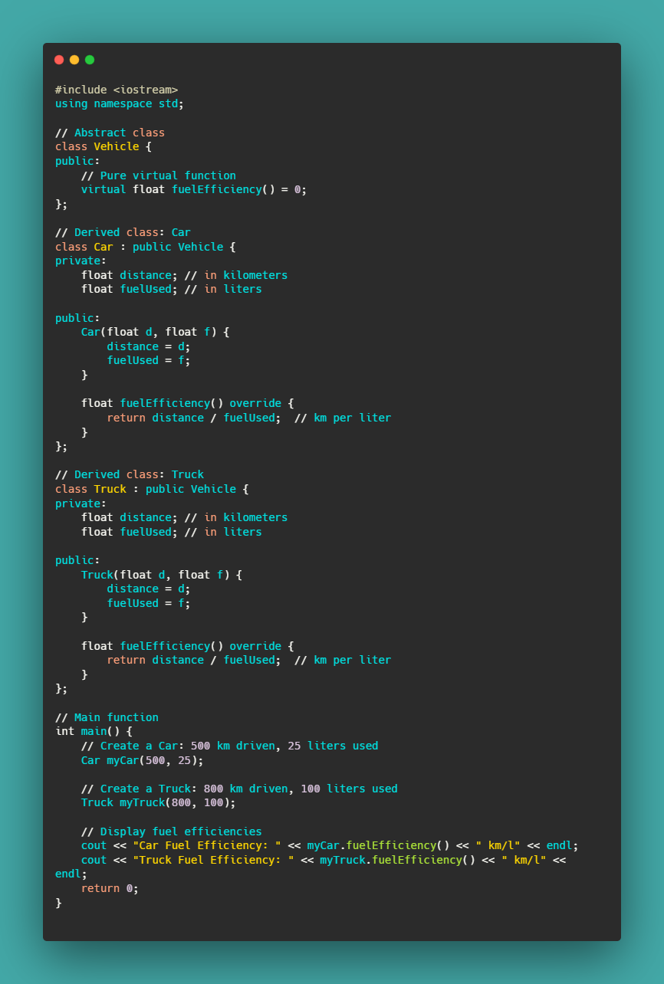Question 4: Create an abstract class Payment with a pure virtual function processPayment(). Derive two classes CreditCardPayment and PaypalPayment from Payment. Implement the processPayment() function in both derived classes. Write a program to process a payment through credit card and PayPal.

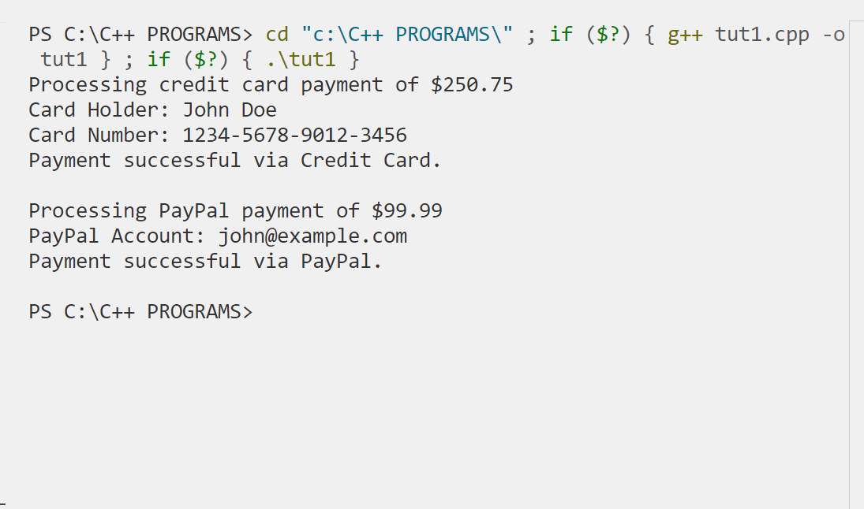

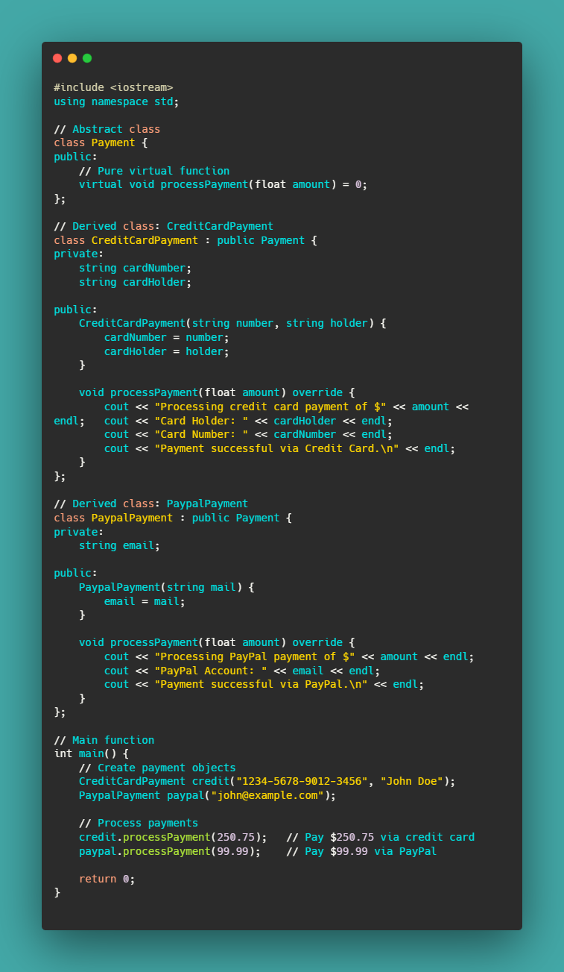Question 5: Create an abstract class Animal with a pure virtual function makeSound(). Derive two classes Dog and Cat from Animal. Implement the makeSound() function in both derived classes. Write a program to simulate the sounds of a dog and a cat.

